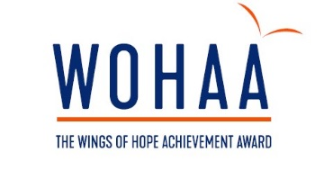 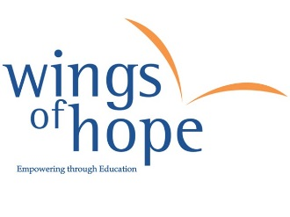
GIFT AID YOUR DONATION TO WINGS OF HOPE

Using Gift Aid means that for every pound you give to the Wings of Hope, we get an extra 25 pence from the Inland Revenue, helping your donation go even further.
This means that a £100.00 could be turned into £125.00, just so long as donations are made through Gift Aid.

Imagine what a difference that could make and it doesn’t cost you a thing…
So if you want your donation to go further, and benefit the Wings of Hope, Gift Aid it!

Just complete this form if you are a UK taxpayer:

I wish the Wings of Hope Children’s Charity to reclaim all tax on all donations I make from this declaration date, until I notify you otherwise. I confirm that I am a UK taxpayer, resident in the UK for tax purposes.

Name: ____________________________________________________
Address:
__________________________________________________________
__________________________________________________________
__________________________________________________________
Post code: ____________________________
Telephone number: ____________________
Date (dd/mm/yy): ______________________

Signature: ____________________________

Please remember:
1. To notify The Wings of Hope if you change your name/ address
2. To notify The Wings of Hope if your circumstances change and you stop paying an amount of income tax or capital gains tax equal to the tax we reclaim on your donation
3. You can cancel the declaration at any time by notifying the Wings of Hope. It will then not apply to donations you make on or after the date of cancellation or such later date as you specify.
4. If you are unsure whether your donation(s) qualify for Gift Aid tax relief, please contact your local tax office for leaflet IR65
5. If you pay tax at the higher rate you can claim further tax relief in your Self Assessment Tax Return

The Wings of Hope Children’s Charity; UK Charity number: 1099685
Wings of Hope, Supreme House, 12 Iron Bridge Close, Great Central Way, London NW10 0UF
www.thewingsofhope.org
The Wings of Hope sponsor the free education for children in developing countries, and nurtures skills and talents for UK children through the Wings of Hope Achievement Award.

THANK YOU

